RESOLUTION NO.__________

RE: CERTIFICATE OF APPROPRIATENESS UNDER THE
PROVISIONS OF THE ACT OF THE PENNSYLVANIA
LEGISLATURE 1961, JUNE 13, P.L. 282 (53
SECTION 8004) AND BETHLEHEM ORDINANCE NO.
3952 AS AMENDED.

WHEREAS, it is proposed to seek approval for the historic plaque location on the exterior of the building at 218 E. Market Street

NOW, THEREFORE, BE IT RESOLVED by the Council of the City of Bethlehem that a Certificate of Appropriateness is hereby granted for the proposal.

Sponsored by: (s)

(s)

ADOPTED BY COUNCIL THIS DAY OF

(s)
President of Council

ATTEST:

(s)
City Clerk

HISTORICAL & ARCHITECTURAL REVIEW BOARD

(Walk-in) The applicant is seeking approval for the historic plaque location on the exterior of the building at 218 E. Market Street.
APPLICATION #3:

Jim & Joanna Ruest
218 E. Market St.
Bethlehem, PA 18018

OWNER:

__________________________________________________________________________

The Board upon motion by Connie Glagola and seconded by Derrick Clark adopted the proposal that City Council issue a Certificate of Appropriateness for the following:

- Two locations approved for the plaques.

- One between the two front windows eye level from the sidewalk or on the
side porch adjacent to the door mounted eye level above the porch floor.

3. The motion was unanimously approved.
__________________________________________________________________________

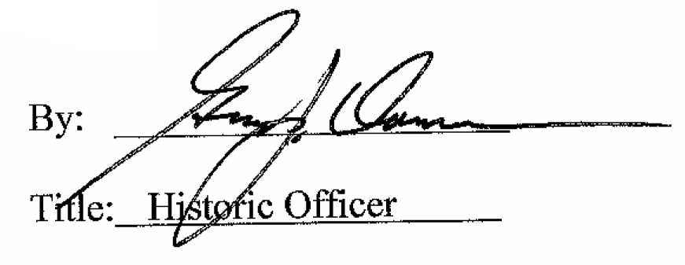

Date of Meeting: February 1, 2017

